BIRLA INSTITUTE OF TECHNOLOGY AND SCIENCE, PILANI
BIO F242/EA C414, INTRODUCTION TO BIOINFORMATICS

SECOND SEMESTER 2013 – 2014
COMPREHENSIVE EXAMINATION (CLOSED BOOK)
Full marks: 70 DATE: 07.05.14 Maximum DURATION: 2 Hrs.
- Answer to the point
- Answer all parts of same question together
- Irrelevant answer may attract penalty
- Steps in each calculation carry marks
1. a) A researcher generates following unrooted and rooted tree by maximum parsimony and UPGMA method with glutamate synthatase gene of Spirulina, Synechocys, Yeast, Arabidopsi and Rice. [1+2+2]
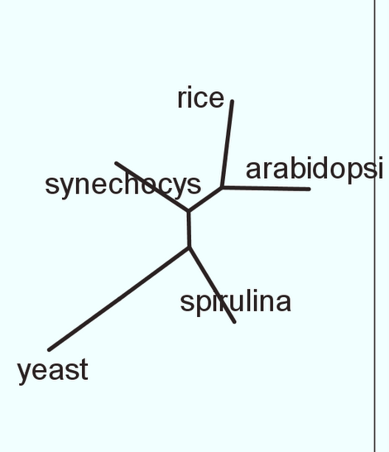
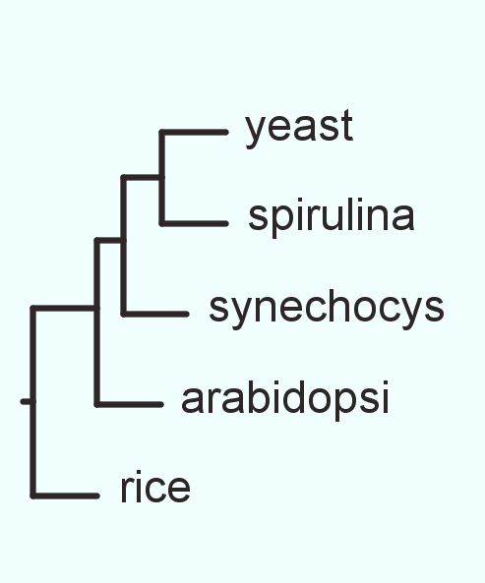

i) How many rooted and unrooted tree are possible for given taxas?
ii) Is it possible to generate the given rooted tree from the given unrooted tree? If so, mention possible root within the given unrooted tree.
iii) Generate possible rooted tree from the given unrooted tree by midpoint or distance method.
b) A researcher was trying to develop PAM250 scoring matrix from a set of related proteins and obtained the following table (partially shown). From the data, comment on authenticity of this scoring matrix. Justify your answer. [3]
 | N | D | E | Q
M | 6 | 5 | 6 | 9
I | 2 | 2 | 2 | 6
L | 4 | 6 | 4 | 5
V | 2 | 5 | 4 | 4
c) For which set of data HMM based MSA algorithm works best. Justify. [2]
2. a) Describe briefly ab-initio method of tertiary structure prediction algorithm. [4]
b) In a typical replication cycle of pcr (thermocycle) reaction, temperatures are generally fixed at 94°C, 60°C and 72°C respectively. However, a technician by mistake set 60°C, 72°C and 94°C respectively. How does it affect pcr product? [4]
c) What is the basis of Chou-Fasman method to consider six residues window to scan entire sequence? [2]
3. a) If you want to draw a phylogenetic tree for all living things what sorts of genes might serve a reasonable taxa? Justify. [2]
b) What is the reason behind considering only informative site in maximum parsimony method?
[2]
c) What would be the most crucial step in threading algorithm? Justify your answer [2]
d) Why does it observe that the pairwise alignment scores (by DP algorithm) of randomly generated sequences does not follow normal distribution? [2]
e) What could be possible reasons for availability of huge protein sequence data (in millions) in comparison to structural data (in thousands)? [2]
4. Explain each term of following expression and usefullness of each expression. [2.5X4=10]
a) Expression of Expection value
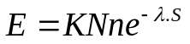

b) Expression of Propensity
P_{ij} = n_{ij}/n_{i} ÷ ∑ n_{ij} / ∑ n_{i}
c) Expression of BLOSUM log-likelihood
S_{ij} = 2log₂[p_{ij}/(p_{i}p_{j})]
d) Expression of maximum-likelihood
Pr(D|T,M)= Π_{i} Pr(D_{i}|T,M)
5. a) The thymine analog 5-bromouracil is a chemical mutagen that induces single base-pair substitutions in DNA. Specifically, 5-bromouracil causes transition mutations. Which of the following amino acid substitutions should you expect to be induced by 5-bromouracil with the highest frequency: (i) Met-->Val (ii) Met-->Leu (iii) Pro-->Arg (iv) Pro-->Gln? Justify your answer. [3]
b) The Yeast genome is approximately 12,000 kb in length and contains about 6000 open reading frames encoding an average of 500 amino acids whereas the Human genome is approximately 3,000,000 kb and contains about 35,000 open reading frames each encoding an average of 500 amino acids. From the above data, comment on the relative level of complexity in gene prediction of these two genome. [2]
c) Is it possible to design a single microarray experiment to estimate relative abundance of total mRNA level in these two genomes (Yeast and Human)? Justify your answer. [3]
d) Nucleic acids extracted from virus X was analyzed for base composition and found to contain 5% percent cytosine and 35% adenine. From this information can you predict percentage of other bases? If so, what percentage? If not, why not? What can you hypothesize about the physical nature of the nucleic acids from virus X? [2]
6. a) Draw the DP traceback path for the following two alignments. [3+2]
i) – GAAT – C ii) – GAAT – C
C – A –T AC C – – AT AC
How could you make one alignment preferred over other?
b) Discuss briefly two common scoring schemes in multiple sequence alignment. [5]
7. Justify or criticize following statements with reasons. [5X2=10]
a) From molecular biology and bioinformatics experiments, a Phd student concluded that protein X is 23% homologous to protein Y.
b) Propensity based secondary structure prediction method is an example of knowledge base prediction method.
c) Default scoring matrix of blastp program is BLOSUM62 which is unreasonable.
d) In HMM based multiple sequence alignment method, transition probabilities are empirical parameters.
e) Sequence analysis of myoglobin gene of all mammals revealed 80% identity in protein level and 88% identity in DNA level.
*********************************Good Luck***********************************
BIRLA INSTITUTE OF TECHNOLOGY AND SCIENCE, PILANI
BIO F242/EA C414, INTRODUCTION TO BIOINFORMATICS

SECOND SEMESTER 2013 – 2014
COMPREHENSIVE EXAMINATION (OPEN BOOK)
Full marks: 35 DATE: 07.05.14 DURATION: 1 Hr.
- Answer to the point
- Answer all parts of same question together
- Irrelevant answer attract penalty
- Steps in each calculation carry marks
1. a) A single nucleotide addition and a single nucleotide deletion approximately 15 sites apart in the DNA cause a change in protein sequence from:
- Lys - Ser - Pro - Ser - Leu - Asn - Ala - Ala - Lys -
to:
- Lys - Val - His - His - Leu - Met - Ala - Ala - Lys -

What are the old and the new mRNA nucleotide sequences? (Use the Table with the genetic code). Which nucleotide has been added and which has been deleted? [3]
b) You are asked to amplify a gene by designing a 15-nucleotide-long primer that could potentially hybridize to a portion of a DNA sequence that encodes the protein sequence N-Met-Ala-Tyr-His-Pro-C. How many different primers would you have to design in order to ensure amplification of gene? [2]

2. From the given multiple sequence alignment of part of DNA sequence of four species construct two phylogenetic trees using UPGMA and NJ. Describe the characteristic features of each tree and compare both trees after converting to rooted tree. [3+4+2+1]

Species-1 ACGCGTTGGGCGATGGCAAC
Species-2 ACGCGTTGGGCGACGGTAAT
Species-3 ACGCATTGAATGATGATAAT
Species-4 ACACATTGAGTGATAATAAT

3. With the help of DOT plot and DP (Needleman-Wunsch) method, establish that these two techniques reveal two different type of information. [2+6+2]

Sequence 1: AWAPQW
Sequence2: PPAW
[Use BLOSUM62 as a scoring matrix and -2 as gap penalty]
4. a) What should be primary criteria to choose template structure in comparative modeling? [2]
b) What is forcefield? How does it affect ab-initio structure prediction? [1+2]
c) Why does threading fall between ab-initio and comparative modeling? [2] d) Suppose a researcher have found that the a protein model generated by comparative modeling is not correct. What would be possible way to rectify the error and generate correct structural model? [3]

*****************************Good Luck***************************************

BLOSUM62 Substitution matrix
